DATA MANAGEMENT SYSTEM

1.1 REQUIREMENTS
Data Management Software shall be designed such that it can store data to monitor key system operating parameters such as IR and Current/Voltage perform waveform analysis and generate reports. The centralised database shall also be capable of storing large amounts of data from the company products, and efficiently personalise based on the client requirements.
- DMS should talk (Handshake) to UNIT in order to fetch the real time data.
- Use this data to show the line graph. Upload csv would still be there as an option.
- UNIT will change data values every second which needs to be captured in to DMS.

1.2 Phases – Full scope of work
The core of the SDMS data monitor and analysis software for the phase-I is the development of IR monitor using the live data stream as well as offline data from the database.
DMS project tasks:
- Upload hardware unit measurement’s CSV file into database to monitor IR.
- Connect to hardware unit and fetch the real time data and store into database to monitor IR.

CSV File Format:
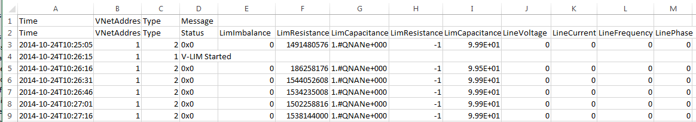

1.3 Hardware Unit:
The hardware unit shall be used as a topside line condition monitor for subsea distribution networks at offshore.

1.4 Access unit through IP address:
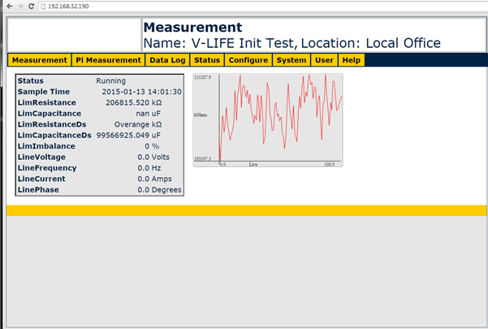
Download Data Logs: (This is accessible thro’ the http://dataLog URL)
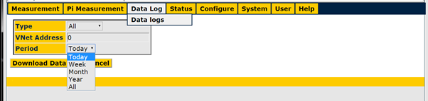
Access configuration file from the unit:
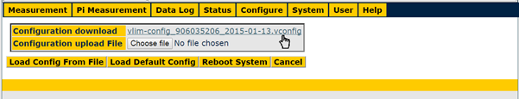
Configuration details:
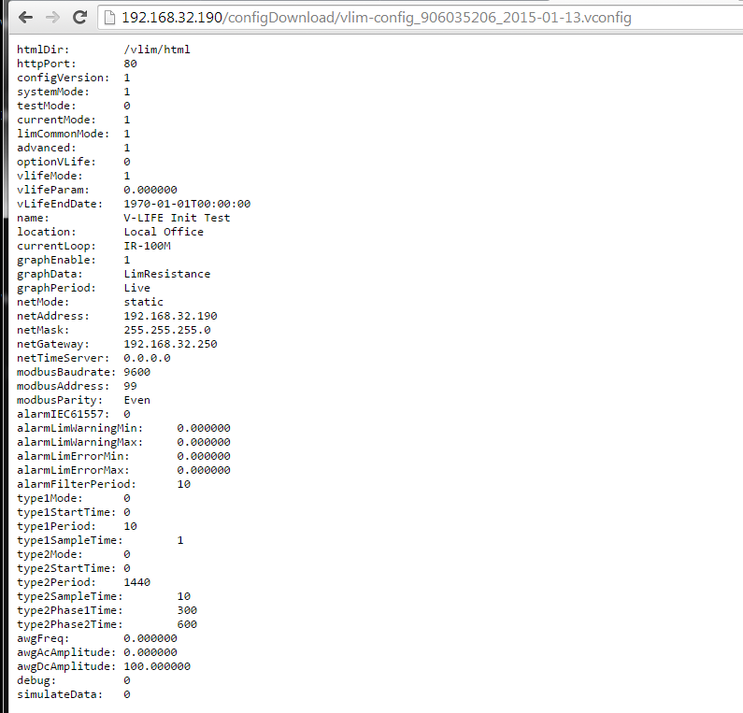
Serial Number of unit:
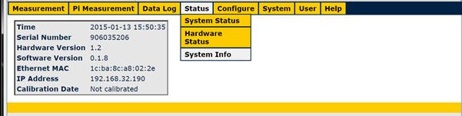

1.5 ESTABLISH CONNECTION TO HARDWARE UNIT
- First DMS should capture the configuration information of UNIT by making a REST call to it. This configuration information should give us the company name, Unit Serial No and the IP address of the UNIT. Store this information either in some form of text files or in Serialized objects. The details of the REST call are given below:
File Name: unit_10.106.20.40.unit
File Content: (JSON Format data)
{"companyName":"ABCABC","unitSerialNo":"XYZXYZ"}

???

Mention the method (GET or PUT or POST or …), URL, Headers required, request parameters and any other options that are essential to fetch the data.

- Then to capture the data you should make another REST call to the same UNIT with different parameters.

???

Mention the method (GET or PUT or POST …) , URL, Headers required, request parameters and any other options that are essential to fetch the data

- Once these information ready, then using this information to persist the data in to the dms tables in database.

- How would you make DMS to talk to many UNITs at a time:

1.5.1 Connections to unit *
UNIT DataLog Download
The V-LIM system provides access to the datalogs via a HTTP interface. This is accessible through the http://dataLog URL. The interface supports parameters by means of POST variables. These are:
Variable | Default | Description
type | All | The type of records to return. Can be: All, Message, Type1 or Type2
vnetAddress | 0 | The VNet address of the unit. 0 means all units, 1 is the topside V-LIM
period | All | Today, Week, Month, Year, All

Variable | Default | Description
startTime |  | If set returns records from this startTime given in Unix epoch seconds UTC. (Not implemented as yet)
endTime |  | If set returns records up to but not including this endTime given in Unix epoch seconds UTC. (Not implemented as yet)

Details from production
- The interface takes parameters in the form of POST data not GET data as I stated. This should not be a problem but I can make it accept parameters in GET (in the URL) form if wanted.

- I have also added documentation for possible "startTime" and "endTime" parameters that would help you with the database work.

- I can provide other parameters for database selection if wanted.

